

**Stuff B Gone**

**Objectives:**

1. Create tables
2. Alter tables
3. Create indexes

**Requirements:**

1. Given the following ERD, create the required tables for Stuff B Gone incorporating the constraints (Primary Key, Foreign Key, Check and Default) and Identity properties as described below. Create each table using a single Create Table statement. **DO NOT** use the Alter Table statement in this question. The symbol (O) indicates a nullable attribute. **(12 marks total)**

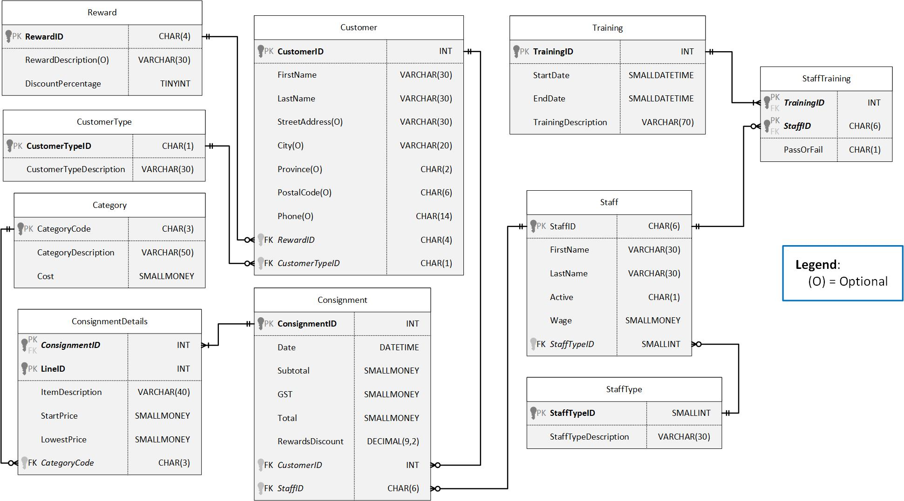

**CONSTRAINTS**

|  |  |  |  |
| --- | --- | --- | --- |
| **Table** | **Column(s)** | **Check** | **Default** |
| Customer | PostalCode | Z9Z9Z9 |  |
| Customer | Province | 2 upper case alpha characters | AB |
| Customer | Phone | 9-999-999-9999 |  |
| Category | Cost | >= 0 |  |
| Training | EndDate, StartDate | EndDate must be after Start Date |  |

Z indicates any upper-case alpha character between A and Z, 9 indicates any digit between 0 and 9

**IDENTITY PROPERTY**

|  |  |  |  |
| --- | --- | --- | --- |
| **Table** | **Column** | **Seed** | **Increment** |
| Customer | CustomerID | 1 | 1 |
| Consignment | ConsignmentID | 1 | 1 |
| StaffType | StaffTypeID | 1 | 1 |
| Training | TrainingID | 1 | 1 |

1. Assuming the tables already have data in them, use the Alter Table statement to alter the tables as described **(4 marks)**
   1. Customer Table: A 30-character optional attribute called email. Email addresses must be a valid email format such as sbell@nait.ca (2 marks)

At least 3 characters before and after @

At least 2 characters after the dot (.)

* 1. Staff Table: A one character attribute called Active_YN that is required and has a default of ‘Y’ (2 marks)

1. Create non-clustered indexes on all foreign keys **(3 marks)**

After you create your tables, you can run the “**Lab 2A Test Data.sql**” file to test your script by inserting data into the tables. If the Test Data script fails at some point, you have errors.

**Submission Requirements**

Your lab submission will include the following:

* A single script file called “**Lab2A_LastName_FirstName.sql**” that contains a clearly commented batch of statements for each requirement. Each batch will contain the SQL statement(s) required to complete each question. **DO NOT** include anything else (test data, random comments, etc.) in your submission.
* An electronic copy of your Lab (not compressed) will be submitted to Moodle
* At the beginning of your SQL script file, add a comment block with a **short** discussion about the lab including:
  + What you liked/disliked about the lab
  + How long it took you to complete the lab
  + How prepared you felt you were for the lab
  + Recommendations for future labs (if any)
  + If there are any known errors in your solution, please identify them in your discussion
* Any additional requirements as specified by your instructor.

**Other Considerations**

Do not make assumptions. If you have questions, ask your instructor. This is not a group project. Working with another student on lab material will result in a grade of **zero (0)** for this lab. Up to 3 Marks may be deducted for incomplete lab submission requirements.